Given a data set a DT is constructed as given below, once DT is constructed it can be used with new query point to identify whether to play tennis or not.

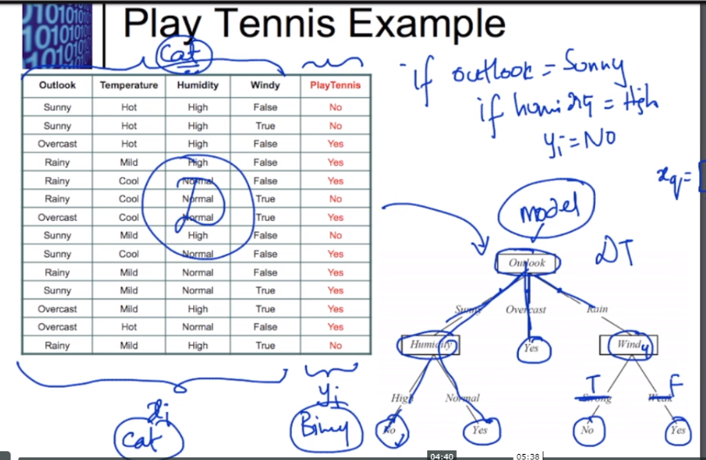

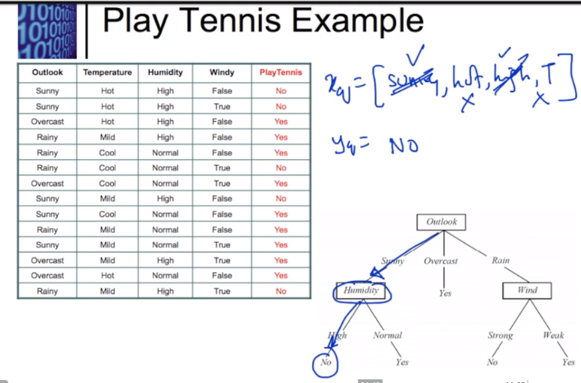

Example is taken from this course lecture: <https://homepage.cs.uri.edu/faculty/hamel/courses/2014/spring2014/csc581/lecture-notes/31-decision-trees.pdf>